Project Development Phase
Model Performance Test

Date | 15 April 2026
Team ID | --
Project Name | Project – Online Fraud Detection System
Maximum Marks | 10 Marks

Model Performance Testing:
Project team shall fill the following information in model performance testing template.
S.No. | Parameter | Values | Screenshot
1. | Metrics | Classification Model:  Confusion Matrix –  Accuray Score-  Classification Report - | 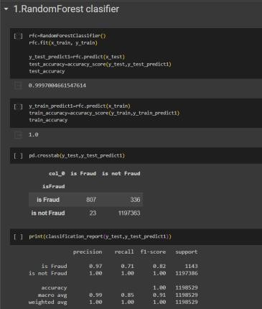  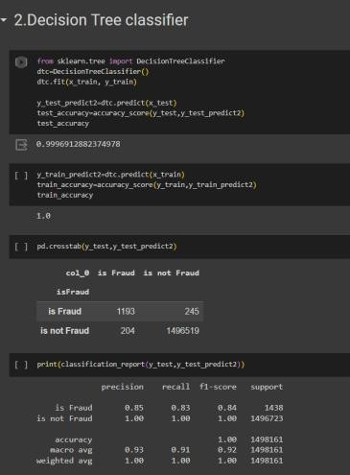
 |  |  | 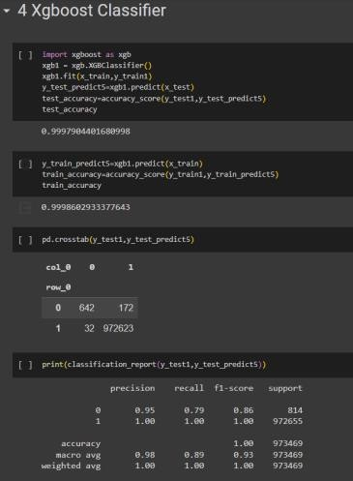
2. | Tune the Model | Hyperparameter Tuning - | The accuracy for the model is high without hyperparameter tunning and the type 2 error is also very low.

